 | Duncan Lake Connections
January 07, 2018
Mission Statement:  In pursuit of excellence, Caledonia Community Schools will empower and equip all persons to achieve their best by ensuring the highest quality system for learning.  Important Reminders:  ^{½ day for students:}  ^{01/23/19}  ^{02/14/19}  Please Note:  This elist is NOT meant to be a complete list of all activities. The goals are to improve communications with parents and students by providing another avenue to highlight as many activities and events as possible.  9757 Duncan Lake Road  Caledonia, MI 49316  Phone:  (616) 891-1380  Fax:  (616) 891-0833  E-mail:  rittengerc@calschools  .org  yonkosk@calschools.org | Principal’s Corner:  Parent and/or Guardian:  I hope that the New Year is off to a great start for you and your families!  It seems that students and faculty are settling into the routine of being back to Duncan Lake Middle School. I hope all of you enjoyed your time with family and found times to be with close friends. Your students will be entering the beginning of the long stretch of little sunlight and long days. Please find time for plenty of sleep and to keep as much joy as possible during the next few months.  A few of our 8th-grade students have been selected to take the National Assessment of Educational Progress (NAEP) exam. This is nothing more than the Nation seeing overall how we are doing in educating our youth as a country. This is a good opportunity for our students to also see how they are doing amongst their peers, not only in Michigan, but also throughout our Nation.  Again, I would like to thank all of you for sharing your wonderful children with us.  Enrichment News:  Duncan Lake Middle School  Enrichment Office  Elizabeth Alexander  891-1380 x7502  Students at the middle school level are encouraged to pursue and enhance their talents and interests. Each year programs are offered to enrich and integrate academics. Available opportunities are published in the DL Connection, communicated through daily announcements and posted outside the Enrichment Office.  AFTER SCHOOL STUDY TABLES–  This awesome program is available for students who want to stay after school to get homework completed or need additional study help. The Study Tables will be available on Tuesdays, Wednesdays and Thursdays.  Before Students May Stay…parents must complete and return the After School Study Table form found in the Main Office or Enrichment Room AND your student must receive their confirmation from the Enrichment Room.  In working with our transportation department, we can provide after school busing for most of our in-district students. Most students will either catch a bus at Caledonia Elementary or ride the Kettle Lake shuttle and pick up a bus at Kettle Lake Elementary.  8TH HOUR PROGRAM –  8th Hour Classes are mostly finished for the Fall. Thank you to all the teachers and parents who gave of their time and creativity to our students!  Our next round of 8th Hour Classes will begin at the end of January 2019. Parents who are interested in sharing their interests and holding a class are invited to contact Mrs. Alexander at alexandere@calschools.org. Past classes by parents have included volleyball, sewing, American Sign Language, fly fishing, and much more.  NATIONAL JUNIOR HONOR SOCIETY – Advisor Mrs. Elizabeth Alexander  NJHS is the nation’s premier organization established to recognize outstanding middle level students.  Thank you to all of the families who donated a gift for our NJHS Angel Tree! Over 70 presents were donated and given to families in need in our community. Other service projects our NJHS students completed this Fall included making fleece blankets for the Grand Rapids Veterans Home and staff appreciation Candy Grams, reading to the preschoolers at the DLECC, sending filled shoeboxes through Operation Christmas Child, and much more.  6th grade is a qualifying year for NJHS. Students must maintain a 3.5 grade point average and participate in at least 6 hours of volunteer service for the community and/or schools to be invited to apply. Current members must also maintain the 3.5 GPA and complete 6 hours of service for the year to remain members in good standing.  STUDENT COUNCIL –  Our next Student Council meeting will be Thursday, December 6th^{st} at 7:30am in the library.  Food Drive Update: Thank you for all of your food donations! Over 1000 items were collected and donated to area food banks, churches, and local families.  ALSO the DLMS Student Council Box Top Collection Competition is in full swing. Each focus class will be competing to see who can collect the most Box Tops to raise money for our school! Please CLIP, CLIP, CLIP!  Box Tops should be sent in with your student to their Focus Class. If you want to help more, please bundle the Box Tops in groups of 50 before sending them in – the Box Tops can be sent in baggies or envelopes. Thank you!  DLMS STUDENT STORE – Mrs. LaValley, Student Store Manager  Open on Thursdays during student lunches!  Come check out the Student Store! Our wonderful parent volunteers, Mrs. LaValley and Mrs. Bont, manage the store and our student workers. They have lots of fun Cal items and new things every week.  KIWANIS BUILDER’S CLUB – Advisor Elizabeth Alexander  Duncan Lake has a very active Kiwanis Builder’s Club...What do we build? Leaders!  All students are welcome to join the DLMS Builder’s Club throughout the year. Our next meeting will be Wednesday, January 16th at 7:30 – 8:00 in Room 302. In December we made candy coated pretzels to be donated to Mary Free Bed. Thank you to our wonderful Kiwanis volunteers – Pastor Jodie and Deb Nordberg – couldn’t have done it without you!  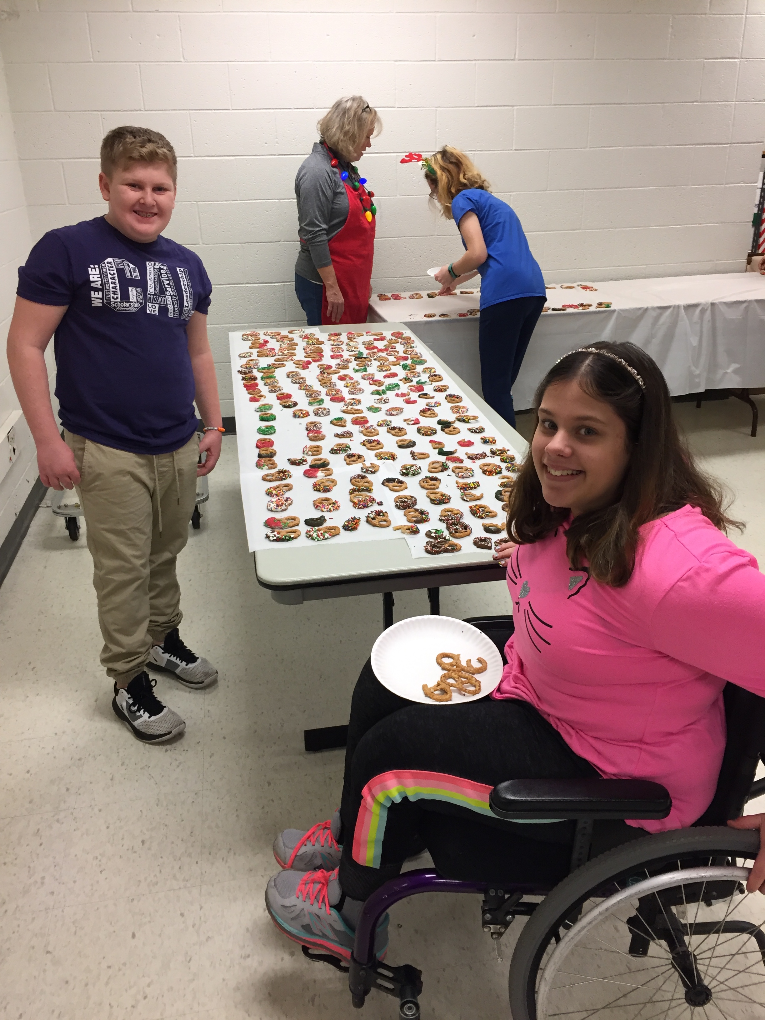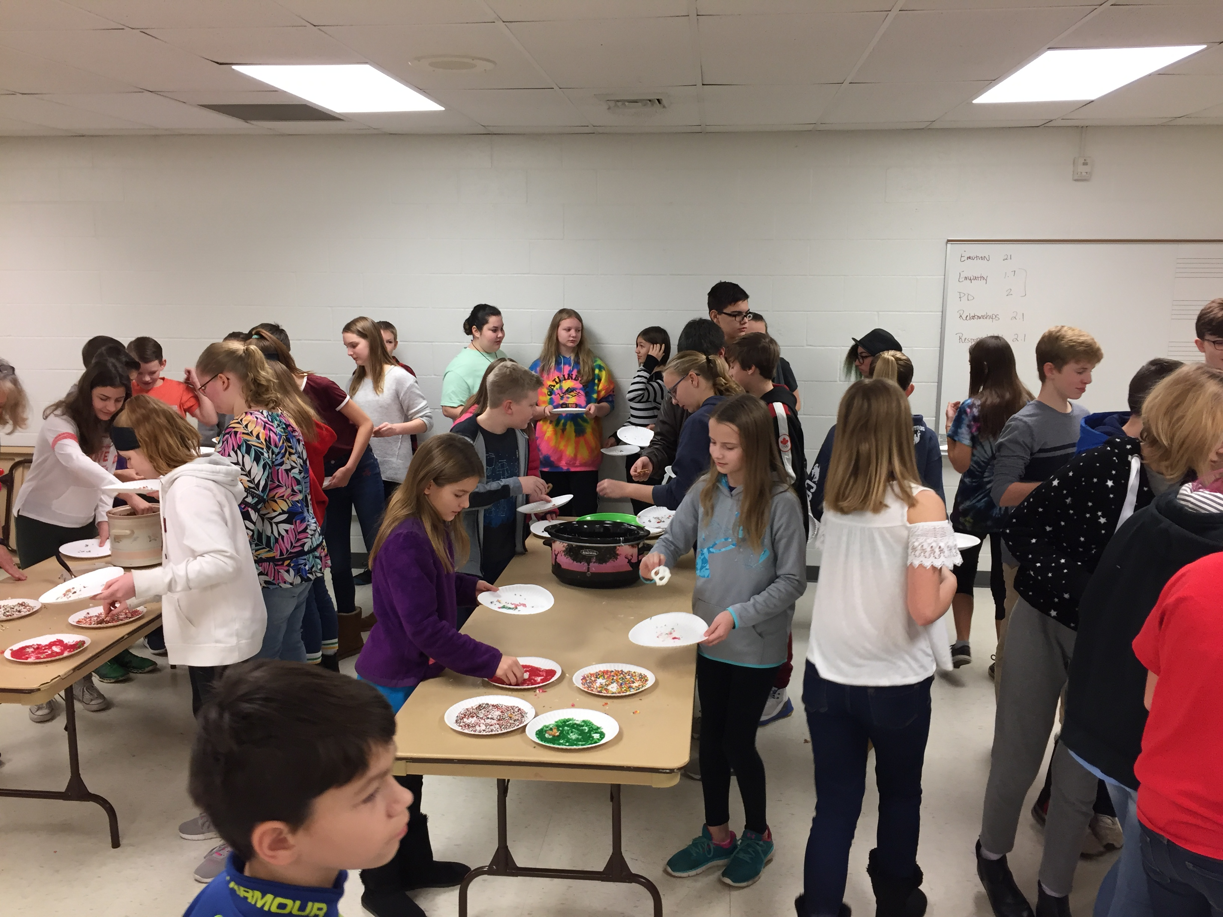  NUMATS 2015-2016 – Northwestern University Midwest Academic Talent Search  Students from 3rd-9th grade can access above grade level tests (9th Grade EXPLORE, SAT, ACT) and receive feedback and assistance in interpreting test results and planning your child’s future education path. If you would like additional information, visit the MATS website at www.ctd.northwestern.edu or see Mrs. Elizabeth Alexander in the Enrichment Office for an information packet.  Sixth and seventh grade students who demonstrate exceptional ability in math or language arts on the NUMATS ACT or SAT tests may qualify for the Kent ISD Academically Talented Youth Program (ATYP). ATYP offers programs in math and language arts that allow students to work at an accelerated pace, depth, and breadth. Please contact Mrs. E. Alexander for more information.  Science Olympiad  SCIENCE OLYMPIAD event practices have begun. Make sure to check for emails with all updates. Event practices will start up weekly again as of the week of January 7th. The next Saturday practices will begin on January 12th.  If you have any questions, please contact Liz Alexander at alexandere@calschools.org  Math Olympiad-  Congratulations to our Math Olympians for successfully completing to monthly competitions!  Mrs. Bravata’s Class:  Students at Duncan Lake Middle School were part of a seven-week 8th hour program where they could learn a new hobby, have fun, and fellowship with other students. The students in Mrs. Bravata’s 8th hour class knitted cowls for the homeless people downtown for God’s Kitchen. Students made as many as they could before Christmas break, especially with cold weather right around the corner. The kids then had the opportunity to travel downtown and deliver the cowls to God’s Kitchen in person. Thank you to the moms that drove the group downtown. The group consists of 16 students; 15 girls and 1 boy. “Donating and helping out is fun!” one student commented on the way home from God’s Kitchen. It is an awesome way for kids to think about others and realize they can make a difference in the community. A special thanks to Henny’s Yarn Shop for donating both the yarn and the circular needles the students knit with. If you have any extra yarn sitting around the house, we would love even more donations for next year is knitting group. Thanks so much.  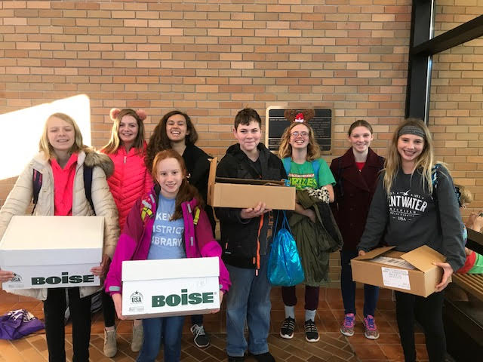  Athletic Department:  Winter II Season: Girl’s Basketball (7^{t}/8^{t} grades): January 14– March 15  Wrestling (6th/7th/8th grades): January 14 – March 15  Spring Season: Track (7th/8th grades): March 18 – May 17  Tennis (6th/7^{t}/8th grades): March 18 – May 17  7th/8th grade Girls Basketball – tryouts begin on Monday, January 14. Tryouts/practices for Girls Basketball will take place as follows: 7th grade girls will have tryouts/practices at Kraft Meadows MS and the 8th grade girls will have tryout/practices at Duncan Lake MS. There is a shuttle bus that will take your athlete from KMMS to DLMS. REMINDER: All students participating in a school sponsored sport must have a completed physical on file, a signed Athletic Code on file and the $75.00 participation fee paid BEFORE he/she can participate.  6th/7th/8th grade Wrestling begins on Monday, January 14 from 3:00 – 4:30 PM at Duncan Lake MS. REMINDER: All students participating in a school sponsored sport must have a completed physical on file, a signed Athletic Code on file and the $75.00 participation fee paid BEFORE he/she can participate.  CALEDONIA GIRLS 5th and 6th GRADE BASKETBALL: Practice will begin the week of January 14 with games starting February 9th running through March 16th. Practice days could be Monday, Tuesday, or Wednesday. Cost is $65.00 per child and includes jersey, To register: Call Caledonia Resource Center at (616) 891-8117 or www.inspiremenow.org.  Community News:  The Caledonia Football Middle School staff will be providing speed, strength, and agility training for ALL athletes currently enrolled in Caledonia Middle School. The training will focus on strength training through using body weights and light weight lifts in the weight room that include benching, squatting, and cleaning. The speed and agility training will focus on footwork, speed training, flexibility, and balance.  The training will run on Monday and Thursday evenings at the High School weight room beginning March 11th and March 14th, and run through the last Thursday of June the 28th from 7pm – 8pm. The lead instructor will be Kevin Tidey who is one of our Middle School coaches and the head baseball coach at Davenport University. The cost of the training is $50. This is a great opportunity to get better whether you can come 6 times or every time. Let us work together to make Caledonia athletics the best it can be. Please email Tom Burrill (Head Varsity Football Coach) at burrillt@calschools.org with any questions.  Shirt Sizes: XS S M L XL  Short Sizes XS S M L XL  Caledonia Community Schools Says Thanks!  Caledonia Community Schools and Aramark Food Service would like to thank you for participating in our electronic deposit system www.sendmoneytoschool.com, and maintaining your students account with positive balances. As a means of saying thanks, Caledonia Community Schools is going to absorb the bank administrative fee of your transaction for the month of January 2019. This is also an effort to save our families a little bit of money, especially after the holidays. As always, our electronic deposit has alleviated the amount of cash the students have to carry internally to pay for their food. The program also allows you as the parent to see what your student is purchasing and eating on a daily basis. If you do not have an account you can create it in a few minutes by going to the web page listed above. Questions on opening your account can be directed to the Food Service Office at (616)891-0227. We try to do our best to promote healthy eating and provide quality meals which include fresh fruit and fresh vegetables daily.  Thank you for your continued support and involvement in your students’ life.  KDL eNews Link:  https://mailchi.mp/kdl/kent-district-library-december-enewsletter?e=6f302cfb03  Caledonia Education Foundation News Link:  https://us9.campaign-archive.com/?e=&u=d184a962d29bc20821323a15f&id=85d26db7e1  Do you want to sell cookie dough? NO! You might recall you received a letter from the PTO during the first week of school. It may have gotten lost in the pile that first week! This is just a little plug that yes, we are attempting to do some fundraising this year WITHOUT selling anything or creating a fancy fundraiser. We would like to continue putting on the following events for our students, staff and community: Open House refreshments (yep - 1,000 cookies!) Make-a-Difference Day (students help the community, we provide snacks), P/T Conference Dinners, Staff Appreciation Week, Bus Garage Appreciation Brunch and 8th Grade Celebration. We would also like to assist with paying for a portion of the field trips and various classroom supplies. If you would like to make a tax-deductible donation, you can simply make a check out to Duncan Lake PTO, and send it in with your child. They can turn it into the office or their focus teacher. Please let us know if you would like a receipt for tax purposes. Thank you for your support!  If you have any questions, please join our Facebook page “Duncan Lake Middle School PTO” and ask us there or email Pam Andrulis atpamandrulis@yahoo.com

